Current fertility cycle

Here you can view and edit your entries for your current fertility cycle.

New fertility cycle

Here you can create a new fertility cycle.

archive

Here you can see past fertility cycles

MENÜ | KALENDER | BEHANDLUNGSPLAN | TAGEBUCH | ARTIKEL
New fertility cycle

Type of fertility treatment

Select fertility treatment ▼

Cycle period

Start calendar icon End Calendar icon

Investigations

Select examination ▼

Treatments

Select treatment ▼

Medication

Add drug

MENÜ | KALENDER | BEHANDLUNGSPLAN | TAGEBUCH | ARTIKEL

New fertility cycle

Type of fertility treatment

Select fertility treatment ▼

Intrauterine insemination without hormonal stimulation
Intrauterine insemination with hormonal stimulation
In vitro fertilization
Intracytoplasmic sperm injection
Cryo treatment
Sexual intercourse also plan

Cycle period

Start calendar End calendar

Investigations
Select examination ▼

Ultrasonic
Blood draw
biopsy
Fallopian tube permeability test
Laparoscopy
Endoscopy

Ultrasonic

Date Calendersymbol
Time Clock symbol
Result ______________
memory Bell to tap

Save
________________________________________________________________________________
Blood draw

Date Calendersymbol
Time Clock symbol
Result ______________
memory Bell to tap

Save

Biopsy

Date Calendersymbol
Time Clock symbol
Result ______________
memory Bell to tap

Save

Fallopian tube permeability test

Date Calendersymbol
Time Clock symbol
Result ______________
memory Bell to tap

Save

Laparoscopy

Date Calendersymbol
Time Clock symbol
Result ______________
memory Bell to tap

Save

Endoscopy
Date Calendersymbol
Time Clock symbol
Result ______________
memory Bell to tap

Save
________________________________________________________________________________

Treatments

Add treatment ▼

Puncture
transfer
insemination

Puncture

Date Calendersymbol
Time Clock symbol
Enter the result How many eggs were punctured? - 0 +
How many eggs are ripe? - 0 +
How many eggs could be fertilized? - 0 +
How many eggs were frozen? - 0 +

memory Bell to tap

Save

Transfer

Date Calendersymbol
Time Clock symbol
Enter the result How many egg cells were used? - 0 +
How many Zeller were there? (Textfeld)
memory Bell to tap

Save

Insemination
Date Calendersymbol
Time Clock symbol
memory Bell to tap

Save

Medication

Add drug

Name________________________ dosage ____________________

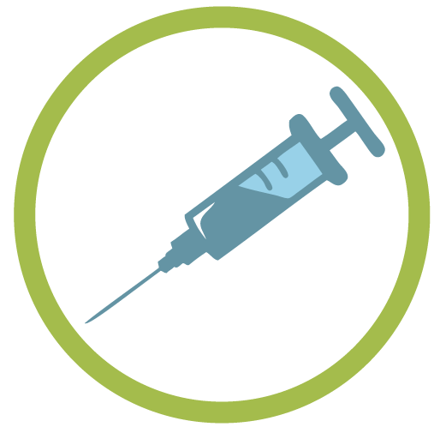
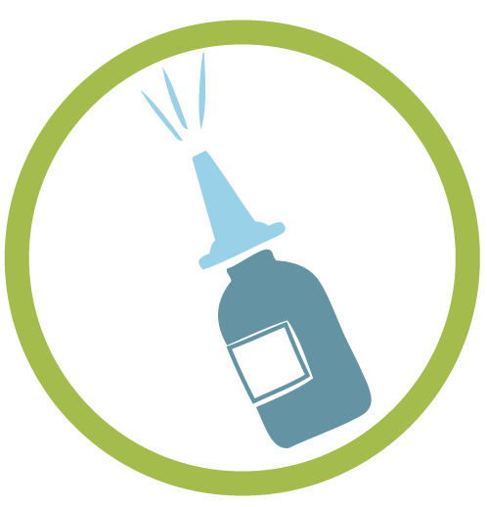
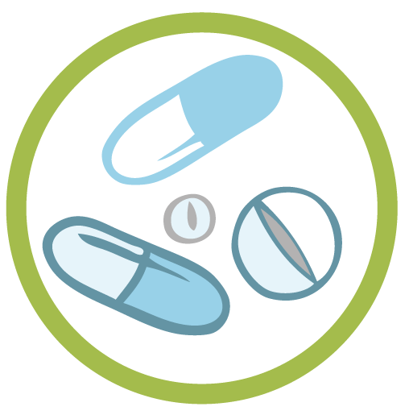

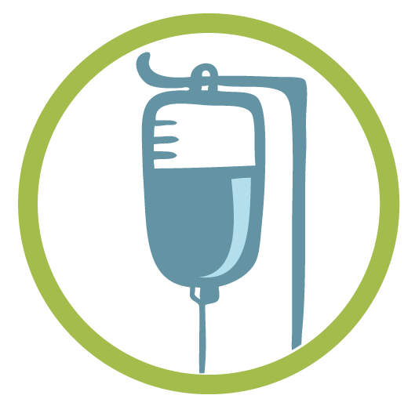

Type of ingestion

Tabletten Spritze/Pen Spray Gel Infusion

number - 0 +
Period Beginning Calendersymbol Ende Calendersymbol
Time Clock symbol
+ further time
memory Bell to tap

Save

MENÜ | KALENDER | BEHANDLUNGSPLAN | TAGEBUCH | ARTIKEL

Current fertility cycle

Type of treatment
Intrauterine insemination with hormonal stimulation

Cycle period
11.04. - 07.05.2020

Investigations

21.04.2020 08:00 Uhr Ultrasonic
Result: 1 follicle on the right 12mm

24.04.2020 08:00 Uhr Blood draw
Result: LH surge

Treatments

25.04.2020 10:00 Uhr Insemination

Medication
12.04.-17.04.2020 08:00 Clomifen
50mg

24.04.2020 09:00 Uhr Ovitrelle
250 Mikrogramm/0,5ml

To edit

MENÜ | KALENDER | BEHANDLUNGSPLAN | TAGEBUCH | ARTIKEL

Edit cycle

Type of treatment
Intrauterine insemination with hormonal stimulation ▼

Cycle period
Start 11.04.2020 Calander Syomble End 07.05.2020 Calander Syomble

Investigations

Select examination ▼

21.04.2020 08:00 Uhr Ultrasonic
Result: 1 follicle right 12mm
24.04.2020 08:00 Uhr Blood draw
Result: LH surge

Treatments

Select treatment ▼
25.04.2020 10:00 Uhr Insemination

Medication

Add drug
12.04.-17.04.2020 08:00 Uhr Clomifen
50mg
24.04.2020 09:00 Uhr Ovitrelle
250 Micrograms /0,5ml

Speichern

MENÜ | KALENDER | BEHANDLUNGSPLAN | TAGEBUCH | ARTIKEL

Wenn man im Bearbeitungsprogramm des aktuellen Kinderwunschzyklus auf folgendes Symbol geht Beispiel Ultraschall + Clomifen

Edit cycle

Type of treatment

Intrauterine insemination with hormonal stimulation ▼

Cycle period

Start 11.04.2020 Calendersymbol End 07.05.2020 Calendersymbol

Investigations

Select examination ▼

Ultraschall

Date 21.04.2020 Calendersymbol
Time 08:00 Clock symbol
Result 1 Follicle on the right 12mm
memory Bell to tap

Save

24.04.2020 08:00 Uhr Blood draw
Result: LH surge

Treatments

Select treatment ▼
25.04.2020 10:00 Uhr Insemination

Medication

Add drug

Name Clomifen dosage 25mg

Income type

Tablet` Syringe / pen Spray Gel Infusion

Period Start 12.04.2020 Calander Symblo End 17.04.2020 Calander Symblo

Time 08:00 Clock symbol
+ further time

memory Bell to tap

Save

24.04.2020 09:00 Uhr Ovitrelle
250 Micrograms /0,5ml

Speichern

MENÜ | KALENDER | BEHANDLUNGSPLAN | TAGEBUCH | ARTIKEL

Archiv

IUI+ 11.04. - 07.05.2020

IVF 08.05. - 05.06.2020

Abbreviations for the calendar and the archive

Intrauterine insemination without hormonal stimulation IUI
Intrauterine insemination with hormonal stimulation IUI+
In-vitro-Fertilisation IVF
Intracytoplasmic sperm injection ICSI
Cryogenic experiment KRY

Puncture PU
Transfer TR
Insemination IN

Ultrasonic US
Blood draw BA
Biopsy BI
Fallopian tube permeability test ELP
Laparoscopy BS
Endoscopy GMS

MENÜ | KALENDER | BEHANDLUNGSPLAN | TAGEBUCH | ARTIKEL

When you go to the archive for fertility treatment

Type of treatment

Intrauterine insemination with hormonal stimulation

Cycle period

11.04. - 07.05.2020

Investigations

21.04.2020 08:00 Uhr Ultrasonic
Result: 1 Follicle on the right 12mm

24.04.2020 08:00 Uhr Blood draw
Result: LH- rise

Treatments

25.04.2020 10:00 Uhr Insemination

Medication
12.04.-17.04.2020 08:00 Clomifen
50mg
24.04.2020 09:00 Uhr Ovitrelle
250 Mikrogramm/0,5ml

To edit

MENÜ | KALENDER | BEHANDLUNGSPLAN | TAGEBUCH | ARTIKEL

